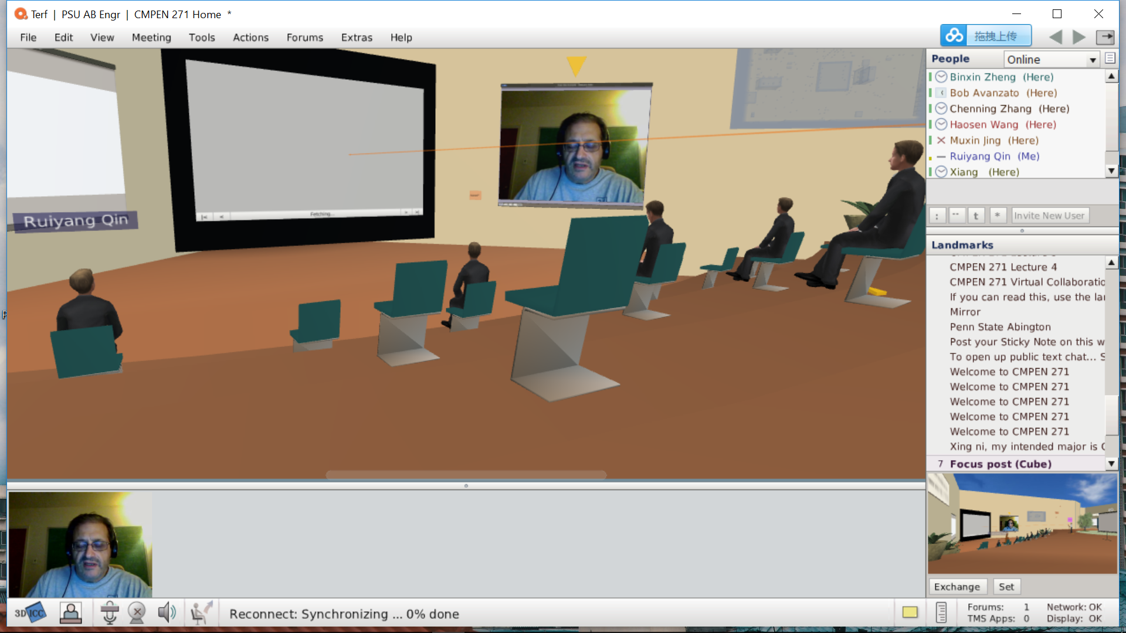

One thing to be clear, I don’t know what’s going on my terf but I just cannot see the screen, it just showing blank. But I do hear the lecture.

The telepresence technology makes me think about si-fi movies where people can make their own robot substitute and do anything for them. Maybe this is still far away from us, but the lecture talking about doctors using the telepresence robot to check patients is a very practical using. By using robots in this way, people somehow save the time to transfer to another physical place. It’s more efficient to and useful to distribute resources. But as I concerned, the quality of the robot and any relevant technological supports are key to this service. It means a very high financial challenge.